
(MILITARY)
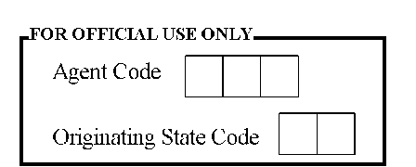
RSA PIN
P | E | N

First name

Middle name

Surname

I would like to update some aspect(s) of my record(s). I hereby authorise you to update the following record(s)

1. SERVICE / FORCE NUMBER:
……………………………………………………………………………………………………………………...................................
2. CURRENT RANK:
……………………………………………………………………………………………………………………...................................
3. GL & STEP 2004 (under harmonized):
……………………………………………………………………………………………………………………...................................
4. GL & STEP 2007 (under consolidated):
……………………………………………………………………………………………………………………...................................
5. GL & STEP 2010 (under enhanced) : ……………………………………………………………………………………………………………………...................................
6. BANK NAME:
……………………………………………………………………………………………………………………...................................
7. ACCOUNT NUMBER (NUBAN):
……………………………………………………………………………………………………………………...................................
8. PFA NAME:
……………………………………………………………………………………………………………………...................................
9. SECOND RSA PIN (IF ANY):
……………………………………………………………………………………………………………………...................................
10. AGENCY:
……………………………………………………………………………………………………………………...................................
11. PHONE NUMBER:
……………………………………………………………………………………………………………………...................................
12. EMAIL ADDRESS:
……………………………………………………………………………………………………………………...................................

___________________________
Signature & Date

For official use only
Supporting document attached

St stamped & signed copy of a Bank confirmation form

________________________________ ________________________________
Received by (CSO Name) Signature & Date

Further enquiries visit our website on:
www.armpension.com
info@armpension.com or 01 271 5000

